July 25, 2013

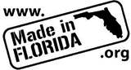
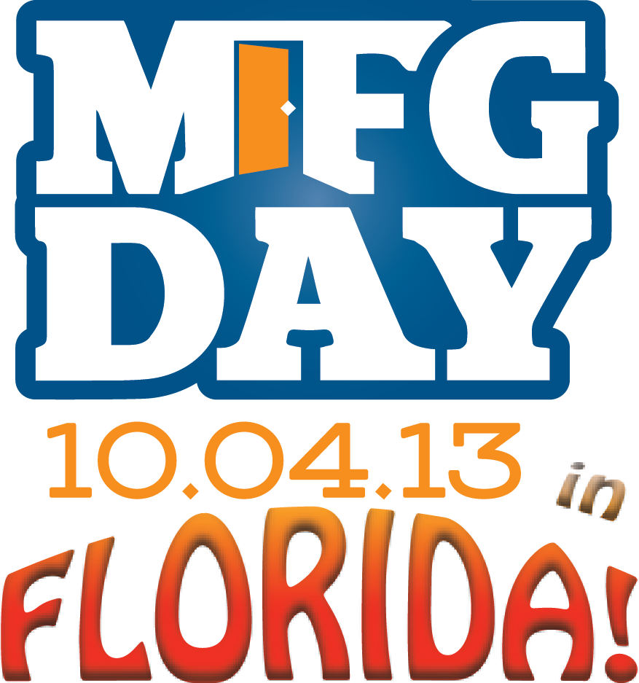
The recent legislative gains for manufacturers in the state of Florida have been won due to the strong and vocal collaboration between industry and education. October 4, 2013 has been designated as National Manufacturing Day. For more information about National MFG Day 2013, please visit http://www.mfgday.com. On this day, manufacturing stakeholders in the State of Florida will again have the opportunity to demonstrate the strength of the manufacturing community in our state. FLATE's goal is to express the necessity of building a strong advanced manufacturing workforce.

FLATE will coordinate “Made in Florida” manufacturing tours for students taking place across the state on October 4th. Your help is needed in the following ways:
- Schools/Districts are providing transportation and chaperones for students
- Manufacturing Companies are offering tours and providing lunch for student groups
- Manufacturing related professional organizations are providing the costs for MFG Day regional t-shirts for students
- FLATE is helping to connect school with companies, arranging media publicity, designing and delivering t-shirts, and surveying students to assess the impact on students in specific regions as well as the overall impact on all participating students

MFG DAY addresses common misperceptions about manufacturing by giving manufacturers an opportunity to open their doors and show, in a coordinated effort, what manufacturing is — and what it isn’t. Hosting a tour or an open house provides manufacturers with an opportunity to tell their company’s story, dispel outdated myths about manufacturing, inspire a new generation of manufacturers, and connect with their communities. Providing lunch and t-shirts to the students provides them with an incentive for turning in the necessary paperwork in order to take the tour. The t-shirts also serve as a tangible reminder of the significance of Manufacturing in Florida.

By joining together on NATIONAL MFG DAY, manufacturers will attract media attention to address the skilled labor shortage they face. As well, companies will connect with future generations, redefine the public image of manufacturing, and ensure the ongoing prosperity of the whole industry. MFG DAY is designed to amplify the voice of individual manufacturers and coordinate a collective chorus of manufacturers with common concerns and challenges.

FLATE will assist industry partners and schools by connecting schools with companies and soliciting support for student lunches and t-shirts. We have set up a webpage on the “Made in Florida” website to support our efforts in Florida and to recognize all who participate. If your company can host a tour and provide student lunches, or your organization can assist with purchasing t-shirts for the student participants, publicity support or anything else, please sign up here, or contact Desh Bagley, FLATE Outreach Manager at bagley@fl-ate.org (813) 253-7838. Desh will follow up with all participants with additional information regarding the statewide Manufacturing Day events.

Please feel free to share this with your organizational membership and others who maybe interested. We look forward to everyone’s participation in Florida’s Manufacturing Day celebrations.

Warm Regards,
Marilyn
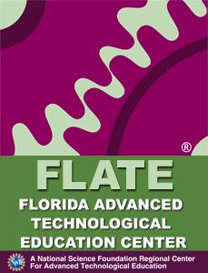
Marilyn Barger, Ph.D., P.E., CPT
PI & Executive Director
Florida Advanced Technological Education Center
A NSF Regional Center of Excellence
Supporting Florida’s Manufacturing Workforce

813.259.6578
barger@fl-ate.org
www.fl-ate.org

